# MPLS VPN跨域C1 C2 带RR

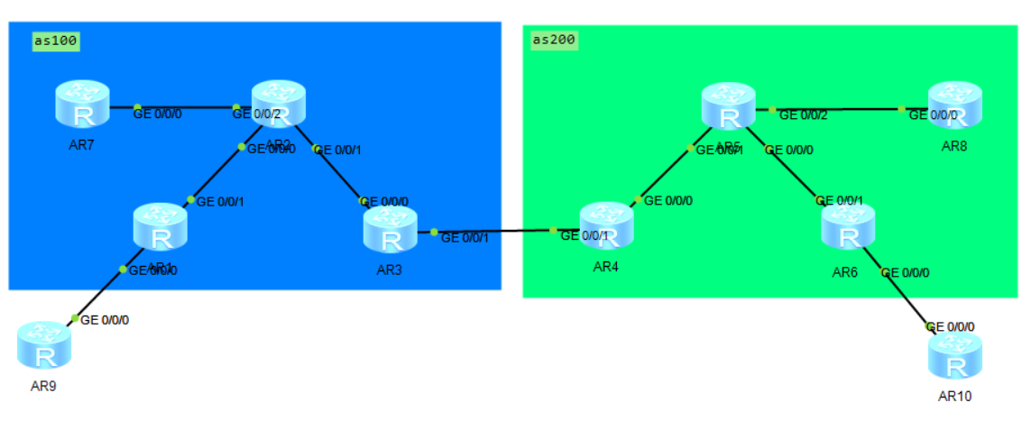

# C1方案

## 1.实验设想

## AR9与AR10采用MPLS BGP Option C1方案互联，总公司CE接入AS100的PE（AR1），分公司CE接入AS200的PE（AR6）。通过精细配置IGP和启用MPLS标签分发，确保数据沿最优路径在AS100与AS200间跨域高效传输。

## 2.拓扑设计

## 

## 3.配置脚本

### 基础配置：

sysname AR1

ip vpn-instance vpn1 //配置实例

ipv4-family

route-distinguisher 1:1

vpn-target 19:19 export-extcommunity

vpn-target 19:19 import-extcommunity

#

mpls lsr-id 1.1.1.1 //配置mpls

mpls

#

mpls ldp

#

interface GigabitEthernet0/0/0

ip binding vpn-instance vpn1 //绑定实例

ip address 19.0.0.1 255.255.255.0

ospf enable 2 area 0.0.0.0

#

interface GigabitEthernet0/0/1

ip address 12.0.0.1 255.255.255.0

ospf enable 1 area 0.0.0.0

mpls

mpls ldp

#

interface LoopBack0

ip address 1.1.1.1 255.255.255.255

ospf enable 1 area 0.0.0.0

#

ospf 2 vpn-instance vpn1

import-route bgp

area 0.0.0.0

sysname AR2

mpls lsr-id 2.2.2.2

mpls

#

mpls ldp

#

interface GigabitEthernet0/0/0

ip address 12.0.0.2 255.255.255.0

ospf enable 1 area 0.0.0.0

mpls

mpls ldp

#

interface GigabitEthernet0/0/1

ip address 23.0.0.2 255.255.255.0

ospf enable 1 area 0.0.0.0

mpls

mpls ldp

#

interface GigabitEthernet0/0/2

ip address 27.0.0.2 255.255.255.0

ospf enable 1 area 0.0.0.0

mpls

mpls ldp

#

interface LoopBack0

ip address 2.2.2.2 255.255.255.255

ospf enable 1 area 0.0.0.0

#

ospf 1 router-id 2.2.2.2

area 0.0.0.0

#

sysname AR3

mpls lsr-id 3.3.3.3

mpls

lsp-trigger bgp-label-route //配置LDP为带标签的公网BGP路由分标签的能力

#

mpls ldp

#

interface GigabitEthernet0/0/0

ip address 23.0.0.3 255.255.255.0

ospf enable 1 area 0.0.0.0

mpls

mpls ldp

#

interface GigabitEthernet0/0/1

ip address 34.0.0.3 255.255.255.0

mpls

#

interface LoopBack0

ip address 3.3.3.3 255.255.255.255

ospf enable 1 area 0.0.0.0

#

ospf 1 router-id 3.3.3.3

area 0.0.0.0

#

sysname AR4

#

mpls lsr-id 4.4.4.4

mpls

lsp-trigger bgp-label-route //配置LDP为带标签的公网BGP路由分标签的能力

#

mpls ldp

#

interface GigabitEthernet0/0/0

ip address 45.0.0.4 255.255.255.0

ospf enable 1 area 0.0.0.0

mpls

mpls ldp

#

interface GigabitEthernet0/0/1

ip address 34.0.0.4 255.255.255.0

mpls

#

interface LoopBack0

ip address 4.4.4.4 255.255.255.255

ospf enable 1 area 0.0.0.0

#

ospf 1 router-id 4.4.4.4

area 0.0.0.0

#

sysname AR5

mpls lsr-id 5.5.5.5

mpls

#

mpls ldp

#

interface GigabitEthernet0/0/0

ip address 56.0.0.5 255.255.255.0

ospf enable 1 area 0.0.0.0

mpls

mpls ldp

#

interface GigabitEthernet0/0/1

ip address 45.0.0.5 255.255.255.0

ospf enable 1 area 0.0.0.0

mpls

mpls ldp

#

interface GigabitEthernet0/0/2

ip address 58.0.0.5 255.255.255.0

ospf enable 1 area 0.0.0.0

mpls

mpls ldp

#

interface LoopBack0

ip address 5.5.5.5 255.255.255.255

ospf enable 1 area 0.0.0.0

#

ospf 1 router-id 5.5.5.5

area 0.0.0.0

sysname AR6

#

ip vpn-instance vpn1

ipv4-family

route-distinguisher 1:1

vpn-target 19:19 export-extcommunity

vpn-target 19:19 import-extcommunity

#

mpls lsr-id 6.6.6.6

mpls

#

mpls ldp

#

interface GigabitEthernet0/0/0

ip binding vpn-instance vpn1

ip address 106.0.0.6 255.255.255.0

ospf enable 2 area 0.0.0.0

#

interface GigabitEthernet0/0/1

ip address 56.0.0.6 255.255.255.0

ospf enable 1 area 0.0.0.0

mpls

mpls ldp

#

interface LoopBack0

ip address 6.6.6.6 255.255.255.255

ospf enable 1 area 0.0.0.0

#

ospf 1 router-id 6.6.6.6

area 0.0.0.0

#

sysname AR7

#

mpls lsr-id 7.7.7.7

mpls

#

mpls ldp

#

interface GigabitEthernet0/0/0

ip address 27.0.0.7 255.255.255.0

ospf enable 1 area 0.0.0.0

mpls

mpls ldp

#

interface LoopBack0

ip address 7.7.7.7 255.255.255.255

ospf enable 1 area 0.0.0.0

#

ospf 1 router-id 7.7.7.7

area 0.0.0.0

#

sysname AR8

mpls lsr-id 8.8.8.8

mpls

#

mpls ldp

#

interface GigabitEthernet0/0/0

ip address 58.0.0.8 255.255.255.0

ospf enable 1 area 0.0.0.0

mpls

mpls ldp

#

interface LoopBack0

ip address 8.8.8.8 255.255.255.255

ospf enable 1 area 0.0.0.0

#

ospf 1 router-id 8.8.8.8

area 0.0.0.0

sysname AR9

interface GigabitEthernet0/0/0

ip address 19.0.0.9 255.255.255.0

ospf enable 1 area 0.0.0.0

#

interface LoopBack0

ip address 9.9.9.9 255.255.255.255

ospf enable 1 area 0.0.0.0

#

ospf 1

area 0.0.0.0

sysname AR10

#

interface GigabitEthernet0/0/0

ip address 106.0.0.10 255.255.255.0

ospf enable 1 area 0.0.0.0

#

interface LoopBack0

ip address 10.10.10.10 255.255.255.255

ospf enable 1 area 0.0.0.0

#

ospf 1

area 0.0.0.0

#

### 重点配置：

AR1:

bgp 100

peer 7.7.7.7 as-number 100 //与AR7 RR建立IBGP关系

peer 7.7.7.7 connect-interface LoopBack0

#

ipv4-family unicast

undo synchronization

peer 7.7.7.7 enable

peer 7.7.7.7 label-route-capability //与AR7 RR开启标签功能

#

ipv4-family vpnv4 // 与AR7 RR建立BGP vpnv4关系

policy vpn-target

peer 7.7.7.7 enable

#

ipv4-family vpn-instance vpn1 //再引入ospf vpn1的路由

import-route ospf 2

#

ospf 2 vpn-instance vpn1 //将bgp vpnv4路由引入ospf vpn1中

import-route bgp

area 0.0.0.0

AR3:

bgp 100

peer 7.7.7.7 as-number 100 //与AR7 RR建立IBGP关系

peer 7.7.7.7 connect-interface LoopBack0

peer 34.0.0.4 as-number 200 //与AR4 as200建立ebgp邻居

#

ipv4-family unicast

undo synchronization

network 1.1.1.1 255.255.255.255 //发布1.1.1.1/32的路由是为了R1/R6接收路由

network 7.7.7.7 255.255.255.255 //发布7.7.7.7/32的路由是为了R7/R8建立vpnv4邻居

peer 7.7.7.7 enable

peer 7.7.7.7 route-policy p2 export //应用p2标签策略出方向

peer 7.7.7.7 next-hop-local

peer 7.7.7.7 label-route-capability //与AR7 RR开启标签功能

peer 34.0.0.4 enable

peer 34.0.0.4 route-policy p1 export //应用p1标签策略出方向

peer 34.0.0.4 label-route-capability //与AR4开启标签功能

#

route-policy p1 permit node 10 //创建p1标签策略，如果收到路由就打上一层标签

apply mpls-label

#

route-policy p2 permit node 10 //创建p2标签策略，如果收到带标签的路由就换层标签

if-match mpls-label

apply mpls-label

#

AR7:

bgp 100

peer 1.1.1.1 as-number 100

peer 1.1.1.1 connect-interface LoopBack0

peer 3.3.3.3 as-number 100

peer 3.3.3.3 connect-interface LoopBack0

peer 8.8.8.8 as-number 200

peer 8.8.8.8 ebgp-max-hop 255

peer 8.8.8.8 connect-interface LoopBack0

#

ipv4-family unicast

undo synchronization

peer 1.1.1.1 enable

peer 1.1.1.1 reflect-client

peer 1.1.1.1 label-route-capability

peer 3.3.3.3 enable

peer 3.3.3.3 reflect-client

peer 3.3.3.3 label-route-capability

peer 8.8.8.8 enable

#

ipv4-family vpnv4

undo policy vpn-target

peer 1.1.1.1 enable

peer 1.1.1.1 next-hop-invariable //传递路由给AR1时不改变下一跳 为了实现路由的最短路径

peer 8.8.8.8 enable

peer 8.8.8.8 next-hop-invariable //传递路由给对端AR8 RR时不改变下一跳

#

route-policy p1 permit node 10

apply mpls-label

#

route-policy p2 permit node 20

if-match mpls-label

apply mpls-label

#

AR4:

bgp 200

peer 8.8.8.8 as-number 200

peer 8.8.8.8 connect-interface LoopBack0

#

ipv4-family unicast

undo synchronization

peer 8.8.8.8 enable

#

ipv4-family vpnv4

policy vpn-target

peer 8.8.8.8 enable

#

ipv4-family vpn-instance vpn1

import-route ospf 2

#

ospf 2 vpn-instance vpn1

import-route bgp

area 0.0.0.0

#

AR5:

bgp 100

peer 1.1.1.1 as-number 100

peer 1.1.1.1 connect-interface LoopBack0

peer 3.3.3.3 as-number 100

peer 3.3.3.3 connect-interface LoopBack0

peer 8.8.8.8 as-number 200

peer 8.8.8.8 ebgp-max-hop 255

peer 8.8.8.8 connect-interface LoopBack0

#

ipv4-family unicast

undo synchronization

peer 1.1.1.1 enable

peer 1.1.1.1 reflect-client

peer 3.3.3.3 enable

peer 3.3.3.3 reflect-client

peer 3.3.3.3 label-route-capability

peer 8.8.8.8 enable

#

ipv4-family vpnv4

undo policy vpn-target

peer 1.1.1.1 enable

peer 1.1.1.1 reflect-client

peer 8.8.8.8 enable

#

AR6:

bgp 200

peer 4.4.4.4 as-number 200

peer 4.4.4.4 connect-interface LoopBack0

peer 6.6.6.6 as-number 200

peer 6.6.6.6 connect-interface LoopBack0

peer 7.7.7.7 as-number 100

peer 7.7.7.7 ebgp-max-hop 255

peer 7.7.7.7 connect-interface LoopBack0

#

ipv4-family unicast

undo synchronization

peer 4.4.4.4 enable

peer 4.4.4.4 reflect-client

peer 4.4.4.4 label-route-capability

peer 6.6.6.6 enable

peer 6.6.6.6 reflect-client

peer 7.7.7.7 enable

#

ipv4-family vpnv4

undo policy vpn-target

peer 6.6.6.6 enable

peer 6.6.6.6 reflect-client

peer 7.7.7.7 enable

#

## 4.总结

数据包传输时走的是最短路径，没有经过RR

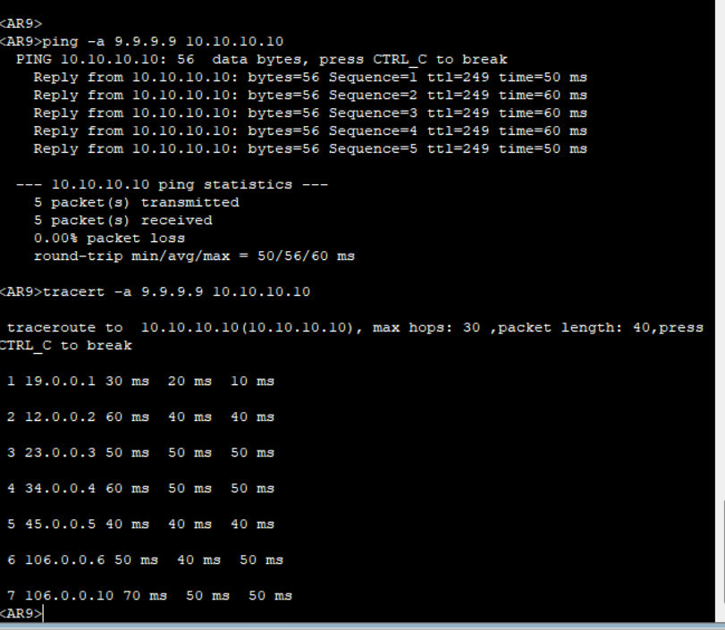

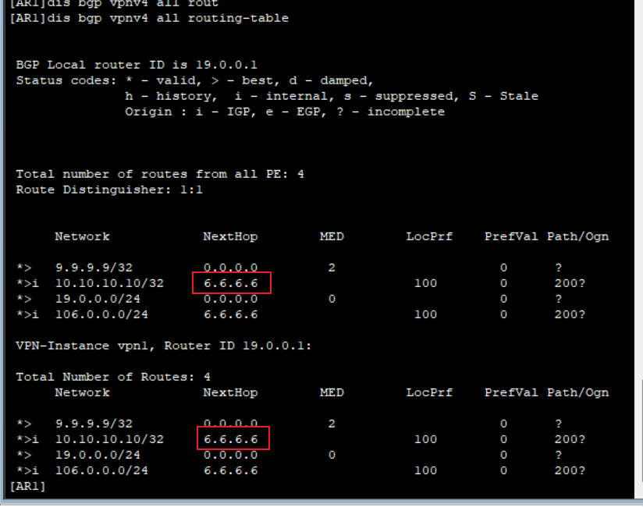

查看ldp标签和内层bgp标签

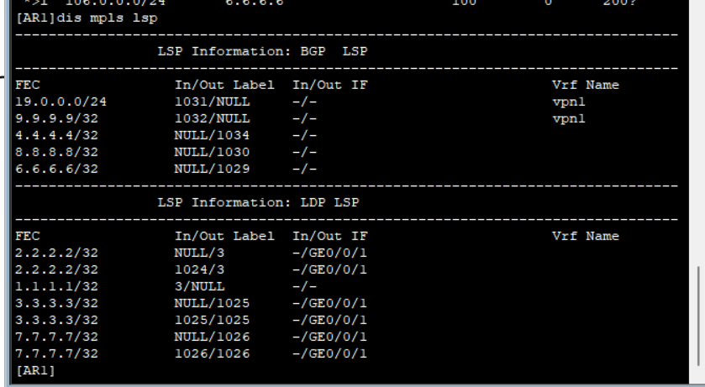

查看10.10.10.10转发表，隧道id 0x9

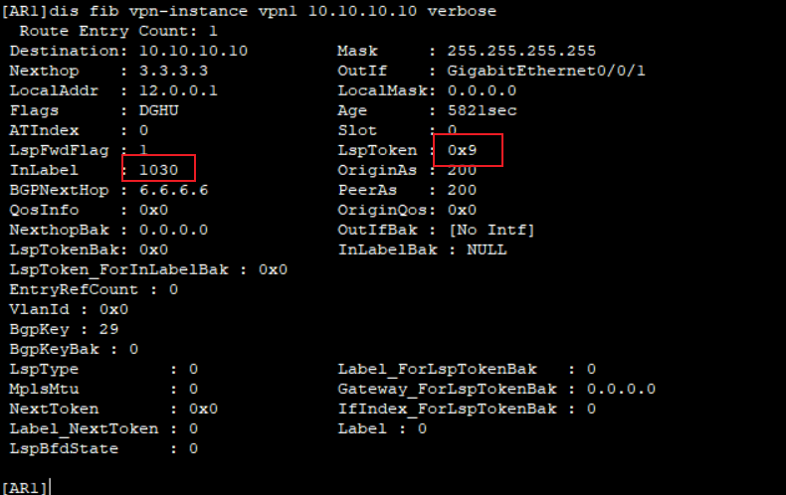

查看隧道0x9，目的为6.6.6.6

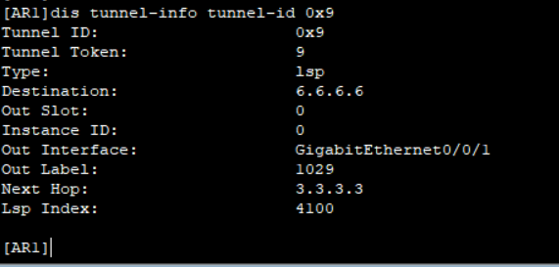

去往6.6.6.6走0x3隧道

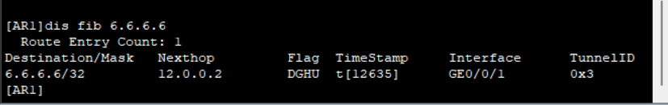

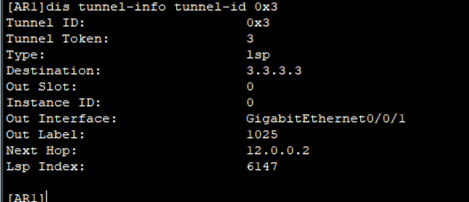

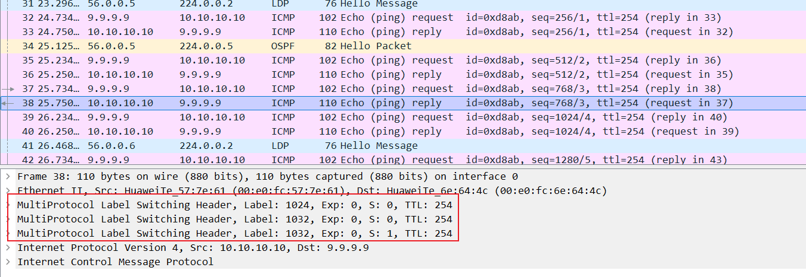

1.在配置BGP（边界网关协议）路由反射器（RR）的过程中，至关重要的一步是启用next-hop-invariable命令。这一配置确保了经过RR反射的路由信息能够保持其原始下一跳信息不变，从而避免路由下一跳错误地指向RR本身，这对于维护网络中的最优路径选择至关重要。

2.当涉及到跨自治系统（AS）配置MPLS（多协议标签交换）时，需要特别注意的一个问题是MPLS并不会自动为BGP转发等价类（FEC）生成标签。为了解决这个问题，我们需要在MPLS配置中明确启用LDP（标签分发协议），以便为公共网络中的BGP路由提供标签分发能力，从而确保数据包能够在MPLS网络中高效地转发。

# C2方案

## 1.实验设想

## AR9与AR10采用MPLS BGP Option C2方案互联，总公司CE接入AS100的PE（AR1），分公司CE接入AS200的PE（AR6）。通过精细配置IGP和启用MPLS标签分发，确保数据沿最优路径在AS100与AS200间跨域高效传输。

## 2.拓扑设计

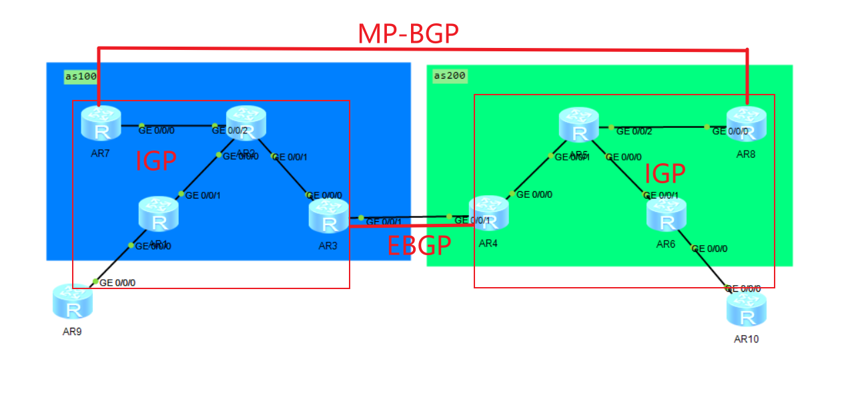

## 3.配置脚本

sysname AR1

#

ip vpn-instance vpn1

ipv4-family

route-distinguisher 100:1

vpn-target 100:1 export-extcommunity

vpn-target 200:6 import-extcommunity

#

mpls lsr-id 1.1.1.1

mpls

#

mpls ldp

#

isis 1

is-level level-2

network-entity 49.0000.0000.0000.0001.00

#

interface GigabitEthernet0/0/0

ip binding vpn-instance vpn1

ip address 19.1.1.1 255.255.255.0

ospf enable 1 area 0.0.0.0

#

interface GigabitEthernet0/0/1

ip address 12.1.1.1 255.255.255.0

isis enable 1

mpls

mpls ldp

#

interface LoopBack0

ip address 1.1.1.1 255.255.255.255

isis enable 1

#

bgp 100

undo default ipv4-unicast

peer 7.7.7.7 as-number 100

peer 7.7.7.7 connect-interface LoopBack0

#

ipv4-family unicast

undo synchronization

undo peer 7.7.7.7 enable

#

ipv4-family vpnv4

policy vpn-target

peer 7.7.7.7 enable

#

ipv4-family vpn-instance vpn1

import-route ospf 1

#

ospf 1 vpn-instance vpn1

import-route bgp

area 0.0.0.0

#

sysname AR2

#

mpls lsr-id 2.2.2.2

mpls

#

mpls ldp

#

isis 1

is-level level-2

network-entity 49.0000.0000.0000.0002.00

#

interface GigabitEthernet0/0/0

ip address 12.1.1.2 255.255.255.0

isis enable 1

mpls

mpls ldp

#

interface GigabitEthernet0/0/1

ip address 23.1.1.2 255.255.255.0

isis enable 1

mpls

mpls ldp

#

interface GigabitEthernet0/0/2

ip address 27.1.1.2 255.255.255.0

isis enable 1

mpls

mpls ldp

#

interface LoopBack0

ip address 2.2.2.2 255.255.255.255

isis enable 1

sysname AR3

#

mpls lsr-id 3.3.3.3

mpls

lsp-trigger bgp-label-route

#

mpls ldp

#

isis 1

is-level level-2

network-entity 49.0000.0000.0000.0003.00

import-route bgp

#

interface GigabitEthernet0/0/0

ip address 23.1.1.3 255.255.255.0

isis enable 1

mpls

mpls ldp

#

interface GigabitEthernet0/0/1

ip address 34.1.1.3 255.255.255.0

mpls

#

interface LoopBack0

ip address 3.3.3.3 255.255.255.255

isis enable 1

#

bgp 100

peer 34.1.1.4 as-number 200

#

ipv4-family unicast

undo synchronization

network 1.1.1.1 255.255.255.255

network 7.7.7.7 255.255.255.255

peer 34.1.1.4 enable

peer 34.1.1.4 route-policy ASBR-Label export

peer 34.1.1.4 label-route-capability

#

route-policy ASBR-Label permit node 10

apply mpls-label

#

sysname AR4

#

mpls lsr-id 4.4.4.4

mpls

lsp-trigger bgp-label-route

#

mpls ldp

#

isis 1

is-level level-2

network-entity 49.0000.0000.0000.0004.00

import-route bgp

#

interface GigabitEthernet0/0/0

ip address 45.1.1.4 255.255.255.0

isis enable 1

mpls

mpls ldp

#

interface GigabitEthernet0/0/1

ip address 34.1.1.4 255.255.255.0

mpls

#

interface LoopBack0

ip address 4.4.4.4 255.255.255.255

isis enable 1

#

bgp 200

peer 34.1.1.3 as-number 100

#

ipv4-family unicast

undo synchronization

network 6.6.6.6 255.255.255.255

network 8.8.8.8 255.255.255.255

peer 34.1.1.3 enable

peer 34.1.1.3 route-policy ASBR-Label export

peer 34.1.1.3 label-route-capability

#

route-policy ASBR-Label permit node 10

apply mpls-label

sysname AR5

#

mpls lsr-id 5.5.5.5

mpls

#

mpls ldp

#

isis 1

is-level level-2

network-entity 49.0000.0000.0000.0005.00

#

interface GigabitEthernet0/0/0

ip address 56.1.1.5 255.255.255.0

isis enable 1

mpls

mpls ldp

#

interface GigabitEthernet0/0/1

ip address 45.1.1.5 255.255.255.0

isis enable 1

mpls

mpls ldp

#

interface GigabitEthernet0/0/2

ip address 58.1.1.5 255.255.255.0

isis enable 1

mpls

mpls ldp

#

interface LoopBack0

ip address 5.5.5.5 255.255.255.255

isis enable 1

sysname AR6

#

ip vpn-instance vpn1

ipv4-family

route-distinguisher 200:6

vpn-target 200:6 export-extcommunity

vpn-target 100:1 import-extcommunity

#

mpls lsr-id 6.6.6.6

mpls

#

mpls ldp

#

isis 1

is-level level-2

network-entity 49.0000.0000.0000.0006.00

#

interface GigabitEthernet0/0/0

ip binding vpn-instance vpn1

ip address 106.1.1.6 255.255.255.0

ospf enable 1 area 0.0.0.0

#

interface GigabitEthernet0/0/1

ip address 56.1.1.6 255.255.255.0

isis enable 1

mpls

mpls ldp

#

interface LoopBack0

ip address 6.6.6.6 255.255.255.255

isis enable 1

#

bgp 200

undo default ipv4-unicast

peer 8.8.8.8 as-number 200

peer 8.8.8.8 connect-interface LoopBack0

#

ipv4-family unicast

undo synchronization

undo peer 8.8.8.8 enable

#

ipv4-family vpnv4

policy vpn-target

peer 8.8.8.8 enable

#

ipv4-family vpn-instance vpn1

import-route ospf 1

#

ospf 1 vpn-instance vpn1

import-route bgp

area 0.0.0.0

sysname AR7

#

mpls lsr-id 7.7.7.7

mpls

#

mpls ldp

#

isis 1

is-level level-2

network-entity 49.0000.0000.0000.0007.00

#

interface GigabitEthernet0/0/0

ip address 27.1.1.7 255.255.255.0

isis enable 1

mpls

mpls ldp

#

interface LoopBack0

ip address 7.7.7.7 255.255.255.255

isis enable 1

#

bgp 100

undo default ipv4-unicast

peer 1.1.1.1 as-number 100

peer 1.1.1.1 connect-interface LoopBack0

peer 8.8.8.8 as-number 200

peer 8.8.8.8 ebgp-max-hop 255

peer 8.8.8.8 connect-interface LoopBack0

#

ipv4-family unicast

undo synchronization

undo peer 1.1.1.1 enable

undo peer 8.8.8.8 enable

#

ipv4-family vpnv4

undo policy vpn-target

peer 1.1.1.1 enable

peer 1.1.1.1 reflect-client

peer 1.1.1.1 next-hop-invariable

peer 8.8.8.8 enable

peer 8.8.8.8 next-hop-invariable

sysname AR8

#

mpls lsr-id 8.8.8.8

mpls

#

mpls ldp

#

isis 1

is-level level-2

network-entity 49.0000.0000.0000.0008.00

#

interface GigabitEthernet0/0/0

ip address 58.1.1.8 255.255.255.0

isis enable 1

mpls

mpls ldp

#

interface LoopBack0

ip address 8.8.8.8 255.255.255.255

isis enable 1

#

bgp 200

undo default ipv4-unicast

peer 6.6.6.6 as-number 200

peer 6.6.6.6 connect-interface LoopBack0

peer 7.7.7.7 as-number 100

peer 7.7.7.7 ebgp-max-hop 255

peer 7.7.7.7 connect-interface LoopBack0

#

ipv4-family unicast

undo synchronization

undo peer 6.6.6.6 enable

undo peer 7.7.7.7 enable

#

ipv4-family vpnv4

undo policy vpn-target

peer 6.6.6.6 enable

peer 6.6.6.6 reflect-client

peer 6.6.6.6 next-hop-invariable

peer 7.7.7.7 enable

peer 7.7.7.7 next-hop-invariable

#

## 4.总结

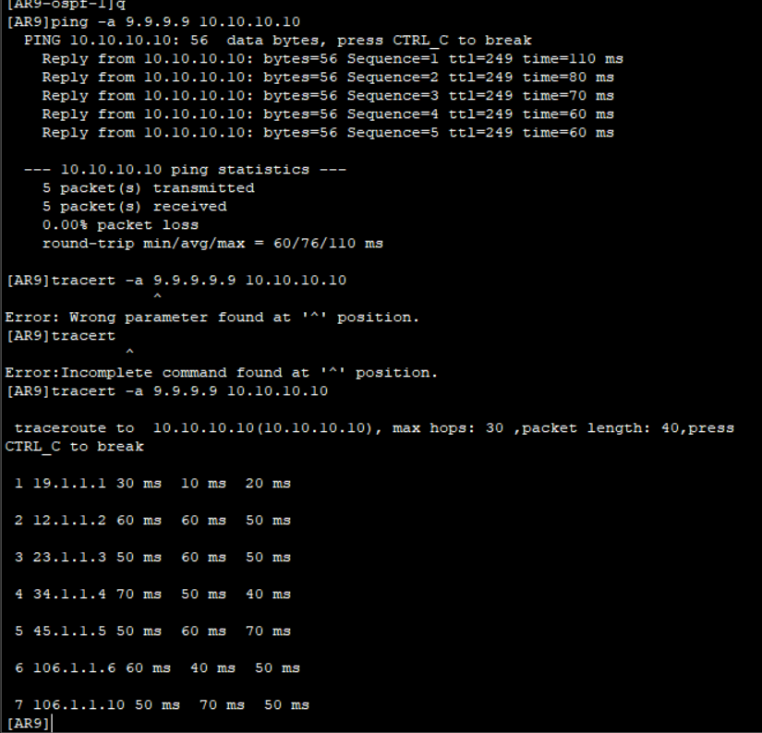

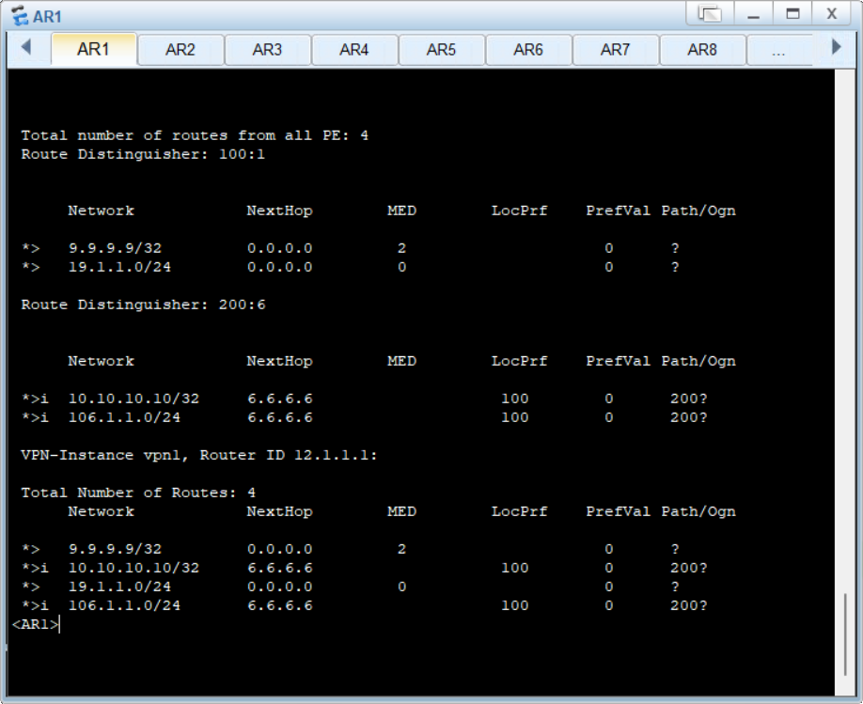

1.在进行相关实验之前，建议首先进行详细的网络架构设计，特别是要构思好Option C1三层标签结构的实现方式；Option C2两层层标签结构的实现方式。这包括如何有效地结合RR的功能，以及如何在BGP邻居之间启用标签功能。可以大大提高实验的效率和成功率，同时也能够确保网络配置的正确性和稳定性。